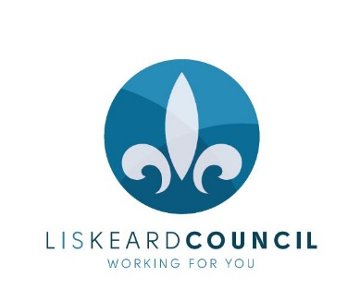
FOR IMMEDIATE RELEASE
CONTACT: Mandy Hancock
PHONE: 01579 345407
EMAIL: assistant@liskeard.gov.uk
14th March 2018
Fair set to be biggest yet!
This year’s Liskeard Community Fair is going to be the biggest and best yet, with over 40 local groups running a variety of fun activities for all ages.
The Community Fair is free and will be held in the Public Hall on Saturday 24th March from 10am – 12.30pm.
Town Councillor Rachel Brooks said: “There’s a real buzz around this year’s Community Fair. There will be lots going on in different rooms at the Public Hall and out on the Parade.”
“Why not have a go at making your own badge with the new Lyskerrys magazine, try giant knitting with 3 Bags Full or play some fun games with Liskeard Bowls Club. It’ll also be a great opportunity to explore all the great things going on in our town and find out how you can get involved.”
Mayor Christina Whitty said: “I’m looking forward to welcoming the wide variety of groups and trying out the activities. We’ll be running a raffle and bric-a-brac stall in aid of the Mayor’s charity which is the Stroke Club, Hillfort and St Martin’s Junior Schools.
The fabulous team from The Real Junk Food Project will providing delicious food, and look out for guest appearances from Cornish dancers Scoots Kernow, the Caradon Youth Choir and the Wham Bam theatre company. If you’re looking for exciting activities for your little ones, pop into the New Liskeard Room where there will be a soft play area and children’s fun with Liskeard Community Action, the Dreadnaught Centre and Creative Relaxation.
Liskeard in Bloom will be there with pot herbs and growing pots and there will also be the chance to buy local crafts, homemade cakes and bric-a-brac from stalls including the Liskerrett Centre, Marie Curie, Inner Wheel and the RNA.
To find out about all of the other great things you can do at this year’s Community Fair, visit www.visitliskeard.co.uk. There really will be something for everyone.
ENDS

